
Symbiosis Institute of Technology, Pune
Faculty of Engineering
CSE- Academic Year 2026-27
Java Programming – Lab Batch 2024-28
Lab Assignment No:- 17
Name of Student: Sanika Botre
PRN No.: 25070122063
Batch: 2025-29
Class: CSE A-2
Academic Year & Semester: 2026 & 3rd Semester
Date of Submission
Title of Assignment: Write a Java program to demonstrate the use of Swing and Applets.

Learning Objectives: To develop graphical user interfaces using Swing components and Applets.

Theory: Swing is Java's GUI toolkit that provides lightweight components such as buttons, labels, text fields, and menus. Applets were small Java programs embedded in web pages for interactive applications. Although Applets are obsolete, Swing remains an important framework for desktop application development. Swing supports platform-independent graphical interfaces.
Practice questions
1. Create a simple Student Registration Form GUI using Swing.

Code:
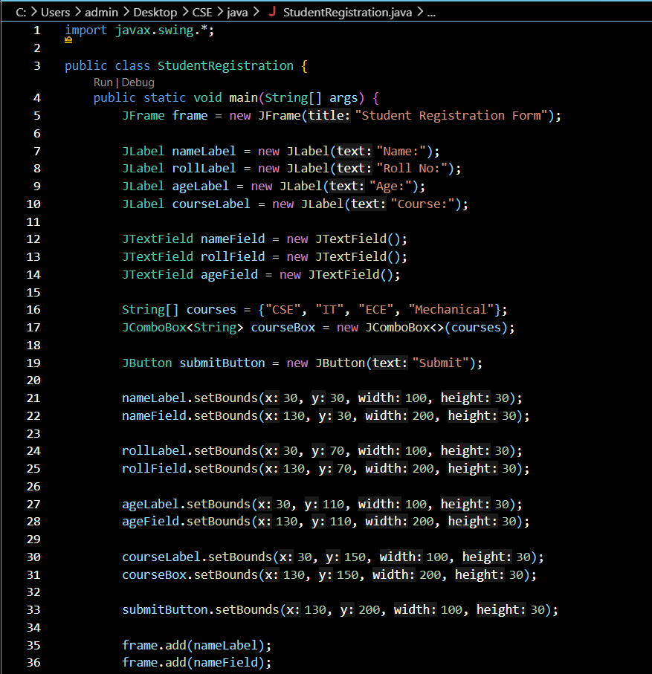
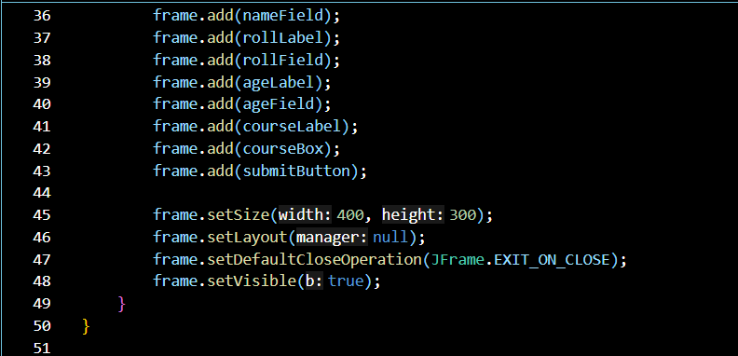

Output:
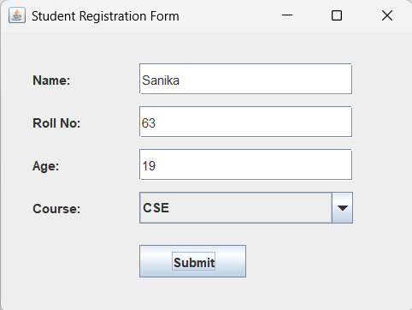

2. Create a simple Employee Registration Form using Java Swing GUI that takes employee details such as Employee ID, Name, Department, and Salary. Display the entered information in a dialog box.
Code:
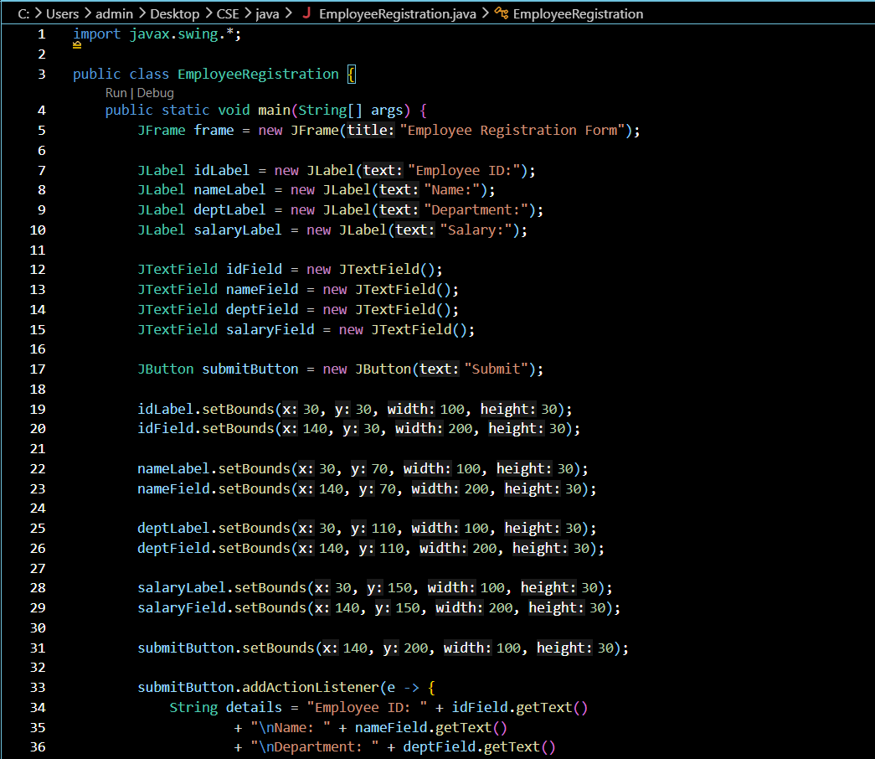
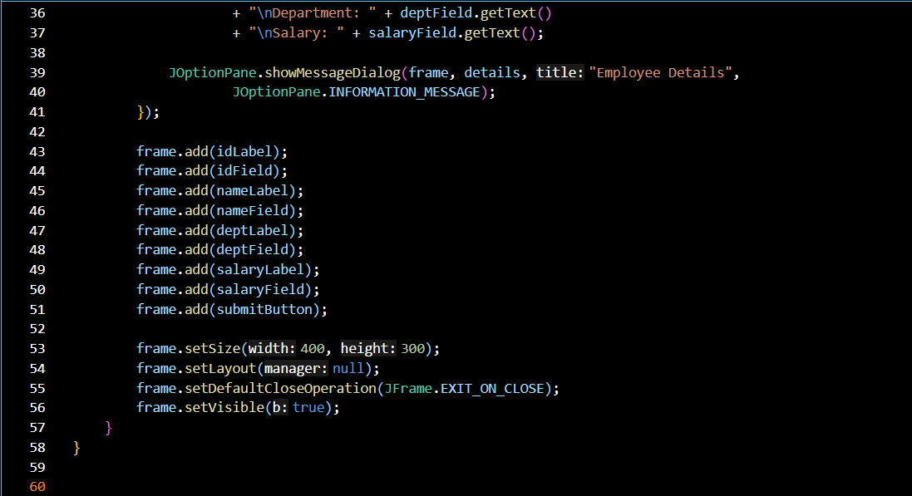
Output:
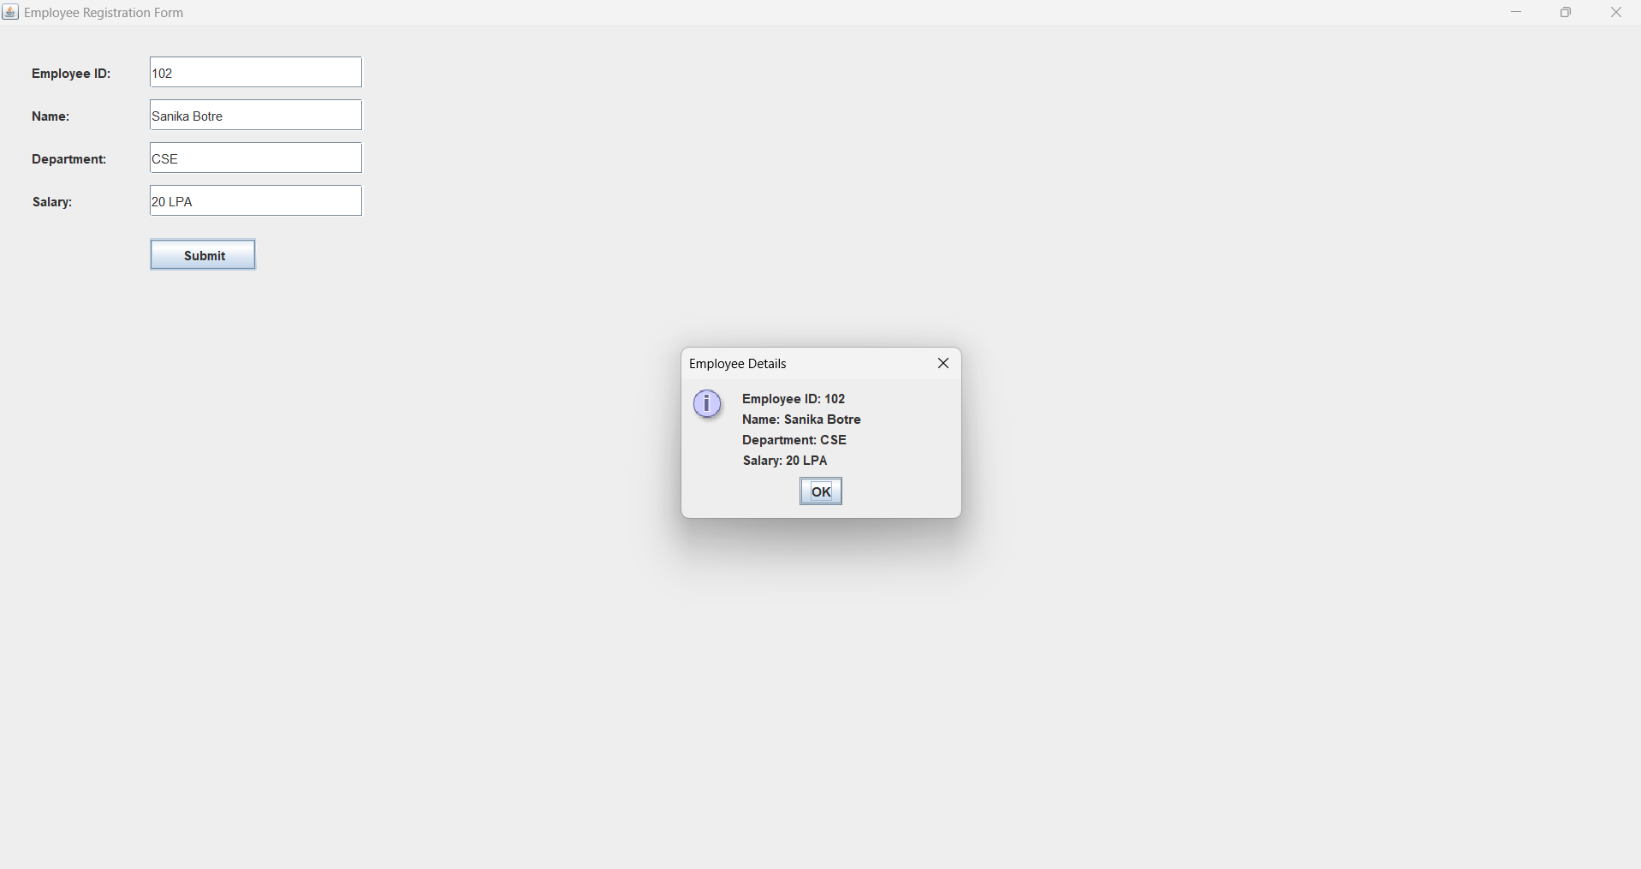

Conclusion
Thus, the Employee Registration Form was successfully designed and implemented using Java Swing GUI components. The program provides a simple and user-friendly interface for entering important employee details such as Employee ID, Name, Department, and Salary. The entered information is collected from the text fields and, on clicking the Submit button, is displayed in a dialog box using JOptionPane. This assignment demonstrates the practical use of Swing components such as JFrame, JLabel, JTextField, JButton, and JOptionPane, along with button click event handling in Java.

